**Forecasting Exercise 1 :**

**Question 1. Explore the data using relevant Graphs.**

First of all I will read the data and split it in test and train sets.

#Set Working Directory

setwd("C:/Users/mmajid1/Desktop/Forecasting")

data_turnover<-read_excel("DataSets.xlsx", sheet="Turnover")

turnover <- ts(data_turnover[,2], frequency = 12, start = c(2000,1))

# Split the data in training and test set

trnovr1 <- window(turnover, end=c(2015,12))

trnovr2 <- window(turnover, start=c(2016,1))|

# Retrieve the length of the test set

h <- length(trnovr2)

Now I will visualize the data.

# Plot the data

plot(turnover)

lines(trnovr1, col="red")

lines(trnovr2, col="blue")

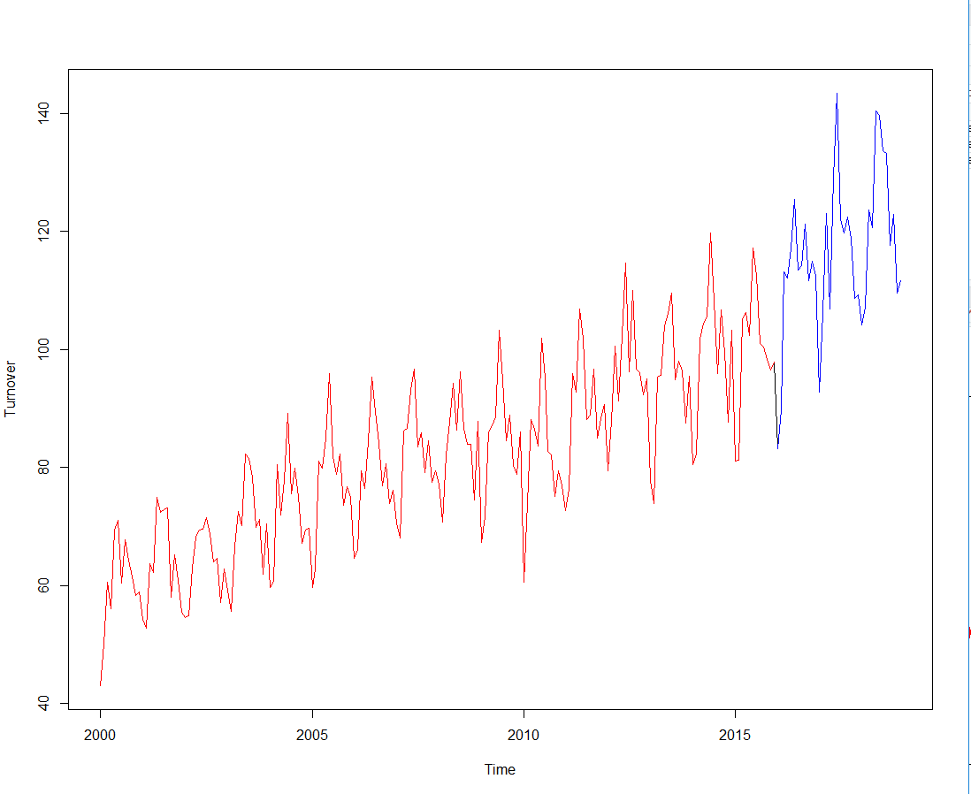

We can observe high seasonality and trend in the time series. Now we will explore seasonality by means of a seasonplot and a monthplot.

par(mfrow=c(1,2))

seasonplot(turnover, year.labels=TRUE, year.labels.left=TRUE,

main="Seasonal plot",

ylab="Turnover",col=rainbow(20), pch=19)

monthplot(turnover, main="Month plot", ylab = "Turnover",

xlab="Month", type="l")

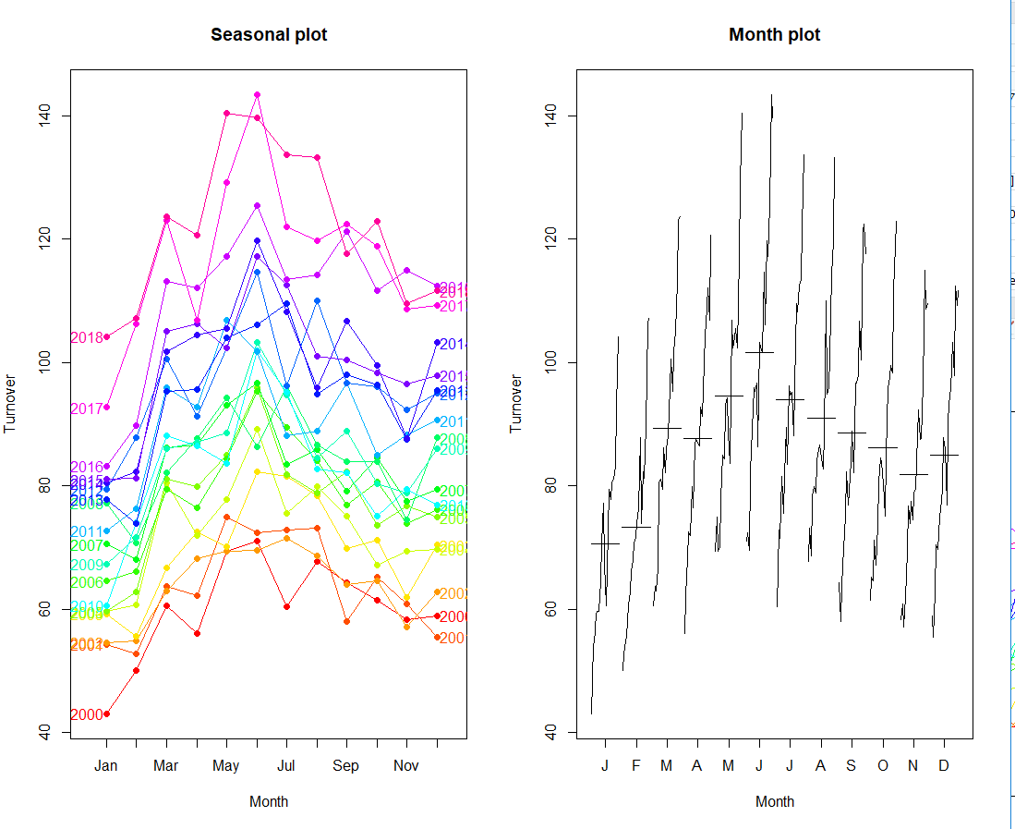

We can see seasonality with a trend. Turnover increases till June and then it starts decreasing.

**Qusetion 2. Forecasts using seasonal naïve methods.**

Given the seasonal pattern in the data, we only consider the seasonal naive as a relevant naive method.

n <- snaive(trnovr1, h=h) # seasonal naive

a_n <- accuracy(n,trnovr2)[,c(2,3,5,6)]

a_train_n <- a_n[1,]

a_train_n

RMSE MAE MAPE MASE

6.612143 5.158722 6.231050 1.000000

a_test_n <- a_n[2,]

a_test_n

|  |
| --- |
| RMSE MAE MAPE MASE  18.545039 16.562222 13.897894 3.210528  plot(turnover,main="Turnover", ylab="",xlab="Month")  lines(n$mean,col=4)  legend("topleft",lty=1,col=c(4),legend=c("Seaonsal naive"))  C:\Users\mmajid1\AppData\Local\Microsoft\Windows\INetCache\Content.Word\123.PNG  By visualization seasonal naïve method is giving us acceptable results.  This can only be judged in comparison with other methods. Now we will check the quality of residuals.  res <- residuals(n)  checkresiduals(n)    Ljung-Box test  data: Residuals from Seasonal naive method  Q* = 70.988, df = 24, p-value = 1.548e-06  Model df: 0. Total lags used: 24  C:\Users\mmajid1\AppData\Local\Microsoft\Windows\INetCache\Content.Word\123.PNG  res <- na.omit(res)  LjungBox(res, lags=seq(1,24,4), order=0)  lags statistic df p-value  1 0.3494086 1 5.544481e-01  5 12.2727058 5 3.123624e-02  9 19.6012334 9 2.053929e-02  13 51.0700802 13 1.951469e-06  17 59.3297691 17 1.355148e-06  21 63.2940998 21 4.001782e-06  The residual diagnostics show that the residuals of this naive method are not white noise.  A forecast on the complete data set based on this method looks as follows:  n_final <- snaive(turnover, h=24)  plot(n_final)  C:\Users\mmajid1\AppData\Local\Microsoft\Windows\INetCache\Content.Word\123.PNG  **Question 3. Forecasts using STL Method.**  we start with an STL decomposition, and use a random walk with drift method to forecast the  Seasonally adjusted time series.  C:\Users\mmajid1\AppData\Local\Microsoft\Windows\INetCache\Content.Word\123.PNG  Now we will plot the various elements that make up the final plot.  C:\Users\mmajid1\AppData\Local\Microsoft\Windows\INetCache\Content.Word\123.PNG  Now we check the accuracy of the forecasts based on a decomposition.  a_d <- accuracy(f_d,trnovr2)[,c(2,3,5,6)]  a_train_d <- a_d[1,]  a_train_d  RMSE MAE MAPE MASE  5.8433289 4.7790812 5.9328465 0.9264079  a_test_d <- a_d[2,]  a_test_d    RMSE MAE MAPE MASE  14.572622 13.095528 10.896998 2.538522  We also check the residuals for STL method.  checkresiduals(f_d)  Ljung-Box test  data: Residuals from STL + Random walk with drift  Q* = 218.63, df = 23, p-value < 2.2e-16  Model df: 1. Total lags used: 24  C:\Users\mmajid1\AppData\Local\Microsoft\Windows\INetCache\Content.Word\123.PNG  res <- na.omit(f_d$residuals)  LjungBox(res, lags=seq(1,24,4), order=1)  LjungBox(res, lags=seq(1,24,4), order=1)  lags statistic df p-value  1 57.94395 0 0  5 83.48917 4 0  9 107.80600 8 0  13 145.55368 12 0  17 161.17936 16 0  21 162.17096 20 0  So the residuals are not white noise. Now we will forecast on the complete dataset.  d_final <- stl(turnover[,1], t.window=15, s.window=13)  trnovradj <- seasadj(d_final)  f_d_final <- forecast(d_final, method="rwdrift", h=23)  plot(f_d_final)  C:\Users\mmajid1\AppData\Local\Microsoft\Windows\INetCache\Content.Word\123.PNG  **Question 4: Forecasts using Holts Winter.**  fc <- hw(turnover,seasonal="mult")  plot(fc)  C:\Users\mmajid1\AppData\Local\Microsoft\Windows\INetCache\Content.Word\123.PNG  There is multiplicative seasonality because of the increasing size of the fluctuations  And increasing variation with the trend. Seasonality also looks good, therefore we will use  Multiplicative.  #exponential trend  fc1 <- hw(turnover,seasonal="mult",exponential=TRUE, h=24)  #damped exponential trend  fc2 <- hw(turnover,seasonal="mult",exponential=TRUE, damped=TRUE, h=24)  #additive damped trend  fc3 <- hw(turnover ,seasonal="mult",damped=TRUE, h=24)  a_fc <- accuracy(fc)[,c(2,3,5,6)]  a_fc1 <- accuracy(fc1)[,c(2,3,5,6)]  a_fc2 <- accuracy(fc2)[,c(2,3,5,6)]  a_fc3 <- accuracy(fc3)[,c(2,3,5,6)]  acc <- rbind(a_fc, a_fc1, a_fc2, a_fc3)  rownames(acc) <- c("a_fc", "a_fc1", "a_fc2", "a_fc3")  acc  RMSE MAE MAPE MASE  a_fc 4.575420 3.665954 4.300099 0.6388534  a_fc1 4.546525 3.625724 4.259526 0.6318427  a_fc2 4.586197 3.667528 4.273690 0.6391277  a_fc3 4.589601 3.698116 4.307876 0.6444583  a_fc1 has the best accuracy measures so we fill chose holt winter exponential trend method.  Now we will check the accuracy.  > fit <- rbind(fc$model$aic, fc1$model$aic, fc2$model$aic, fc3$model$aic)  > colnames(fit) <- c("AIC")  > rownames(fit) <- c("a_fc", "a_fc1", "a_fc2", "a_fc3")  > fit  AIC  a_fc 1954.442  a_fc1 1953.686  a_fc2 1958.690  a_fc3 1958.793  here also fc1 is the best.  > checkresiduals(fc1)  Ljung-Box test  data: Residuals from Holt-Winters' multiplicative method with exponential trend  Q* = 120.16, df = 8, p-value < 2.2e-16  Model df: 16. Total lags used: 24    We can see there is no white noise in this model.  **Question 5 Forecasting using ETS.**  In this section we apply seasonal ETS models to the turnover data. Based on the properties of the data,  we estimate several ETS models with a trend and a seasonal component.  We consider additive and multiplicative errors, and trends with and without damping.  Excluding two models that are possibly unstable, we end up with six candidate models.  #Models without damping (excluding possibly unstable models)  e1 <- ets(trnovr1, model="AAA")  e2 <- ets(trnovr1, model="MAA")  e3 <- ets(trnovr1, model="MAM")  e4 <- ets(trnovr1, model="MMM")  #Models with damping (excluding possibly unstable models)  e5 <- ets(trnovr1, model="AAA", damped=TRUE)  e6 <- ets(trnovr1, model="MAA", damped=TRUE)  e7 <- ets(trnovr1, model="MAM", damped=TRUE)  e8 <- ets(trnovr1, model="MMM", damped=TRUE)  We want to compare AICc as model ﬁt criterion, and MASE and RMSE for the training and test set to  assess forecast accuracy.  This is realized with the following code (note: the models considered here are the same as e1, ..., e8 above):  m <- c("AAA", "MAA", "MAM", "MMM")  result <- matrix(data=NA, nrow=4, ncol=9)  for (i in 1:4){  model <- ets(trnovr1, model=m[i], damped=FALSE)  f <- forecast(model, h=length(trnovr2))  a <- accuracy(f, trnovr2)  result[i,1] <- model$aicc  result[i,2] <- a[1,2]  result[i,3] <- a[1,3]  result[i,4] <- a[1,5]  result[i,5] <- a[1,6]  result[i,6] <- a[2,2]  result[i,7] <- a[2,3]  result[i,8] <- a[2,5]  result[i,9] <- a[2,6]  }  rownames(result) <- m  result[,1] # Compare AICc values  AAA MAA MAM MMM  1615.019 1614.158 1596.780 1600.785  a_train_e1 <- result[,2:5]  colnames(a_train_e1) <- c("RMSE", "MAE", "MAPE", "MASE")  a_train_e1  RMSE MAE MAPE MASE  AAA 4.389998 3.549698 4.474374 0.6880964  MAA 4.395102 3.535720 4.464581 0.6853868  MAM 4.288583 3.367403 4.193484 0.6527591  MMM 4.341217 3.399736 4.233628 0.6590268  a_test_e1 <- result[,6:9]  colnames(a_test_e1) <- c("RMSE", "MAE", "MAPE", "MASE")  a_test_e1  RMSE MAE MAPE MASE  AAA 12.346438 10.792940 8.923883 2.092173  MAA 11.785435 10.211070 8.434245 1.979380  MAM 11.342828 9.932995 8.337017 1.925476  MMM 9.610055 8.152183 6.854579 1.580272  The non-damped MAM model shows the best AICc. Forecast accuracy results on the training set  are comparable over the models, but on the test set the non-damped MMM model outperforms the other models.  Repeating the same procedure for the damped models, we get the following table:  m <- c("AAA", "MAA", "MAM", "MMM")  result <- matrix(data=NA, nrow=4, ncol=9)  for (i in 1:4){  model <- ets(trnovr1, model=m[i], damped=TRUE)  f <- forecast(model, h=length(trnovr2))  a <- accuracy(f, trnovr2)  result[i,1] <- model$aicc  result[i,2] <- a[1,2]  result[i,3] <- a[1,3]  result[i,4] <- a[1,5]  result[i,5] <- a[1,6]  result[i,6] <- a[2,2]  result[i,7] <- a[2,3]  result[i,8] <- a[2,5]  result[i,9] <- a[2,6]  }  rownames(result) <- m  result[,1]  AAA MAA MAM MMM  1623.666 1619.379 1602.953 1602.489  a_train_e2 <- result[,2:5]  colnames(a_train_e2) <- c("RMSE", "MAE", "MAPE", "MASE")  a_train_e2  RMSE MAE MAPE MASE  AAA 4.461580 3.615481 4.529685 0.7008481  MAA 4.476053 3.595474 4.479015 0.6969699  MAM 4.306913 3.412253 4.226032 0.6614532  MMM 4.296421 3.389736 4.198097 0.6570883  a_test_e2 <- result[,6:9]  colnames(a_test_e2) <- c("RMSE", "MAE", "MAPE", "MASE")  a_test_e2  RMSE MAE MAPE MASE  AAA 15.82486 14.26125 11.84684 2.764492  MAA 16.55432 14.94881 12.41871 2.897773  MAM 15.52682 14.01622 11.74657 2.716994  MMM 15.38008 13.87397 11.62868 2.689420  The damped MMM model shows the best AICc. Again, the forecast accuracy results on the training set are  comparable over the models, on the test set the damped MMM and MAM models are performing good but comparable to others.  We select the damped MMM model. This is the Holt-Winters seasonal method with damping.  summary(e8)  ETS(M,Md,M)  Call:  ets(y = trnovr1, model = "MMM", damped = TRUE)  Smoothing parameters:  alpha = 0.1527  beta = 0.0032  gamma = 1e-04  phi = 0.979  Initial states:  l = 57.9942  b = 1.0072  s = 0.9626 0.9219 0.9754 1.0082 1.0448 1.0868  1.174 1.0904 1.0249 1.0357 0.845 0.8304  sigma: 0.0555  AIC AICc BIC  1598.535 1602.489 1657.170  Training set error measures:  ME RMSE MAE MPE MAPE MASE ACF1  Training set 0.3914648 4.296421 3.389736 0.1964789 4.198097 0.6570883 -0.154588  We check the properties of the residuals for this model.    Ljung-Box test  data: Residuals from ETS(M,Md,M)  Q* = 106.89, df = 7, p-value < 2.2e-16  Model df: 17. Total lags used: 24    We can see there is no white noise here.  We compare the results with those of the automated ETS procedure.  > auto_ets <- ets(trnovr1)  > auto_ets$method  [1] "ETS(M,A,M)"  > f <- forecast(auto_ets, h=length(trnovr2))  > accuracy(f, trnovr2)[,c(2,6)]  RMSE MASE  Training set 4.288583 0.6527591  Test set 11.342828 1.9254758  checkresiduals(auto_ets)  Ljung-Box test  data: Residuals from ETS(M,A,M)  Q* = 98.699, df = 8, p-value < 2.2e-16  Model df: 16. Total lags used: 24    The MAM model shows the best fit (measured as AICc). However, this is not the model with the best  performance in terms of forecast accuracy. Our final choice among the ets models therefore is the MMdM model,  although we recognize that the residuals of this model do not behave well. We fit the model to the complete  data set and generate forecasts up to the end of 2020.  e_final <- ets(turnover, model = "MMM", damped = TRUE)  e_final_f <- forecast(e_final, h=24)  plot(e_final_f)    **Question 6: Forecasts using ARIMA.**  We further investigate the characteristics of the time series.  tsdisplay(trnovr1, main="Turnover", ylab="Turnover", xlab="Year")  C:\Users\mmajid1\AppData\Local\Microsoft\Windows\INetCache\Content.Word\123.PNG  The ACF shows that non stationarity is being caused by seasonality and trend to a lesser extent.  We start by diﬀerencing the data (the ndiffs function suggests one diﬀerence).  Next, the nsdiffs function also suggest difference of 1.  > ndiffs(trnovr1)  [1] 1  > nsdiffs(trnovr1)  [1] 1  The characteristics of the double diﬀerenced time series are as follows  tsdisplay(diff(diff(trnovr1,12)), main="Single Differenced Turnover", ylab="Turnover Index", xlab="Year") |
|  |
| |  | | --- | |  | |

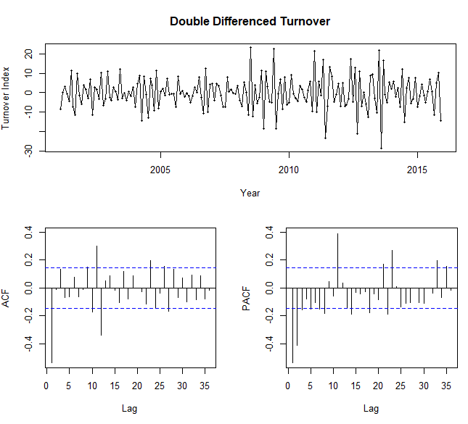

**Model Estimation**

We start with the auto.arima procedure to get a ﬁrst idea of a suitable model. We disable the stepwise and approximate search, and ask for ﬁrst and seasonal diﬀerences.

m0 <- auto.arima(trnovr1, stepwise = FALSE, approximation = FALSE, d=1)

checkresiduals(m0)

Ljung-Box test

data: Residuals from ARIMA(3,1,1)(0,1,1)[12]

Q* = 47.368, df = 19, p-value = 0.0003163

Model df: 5. Total lags used: 24

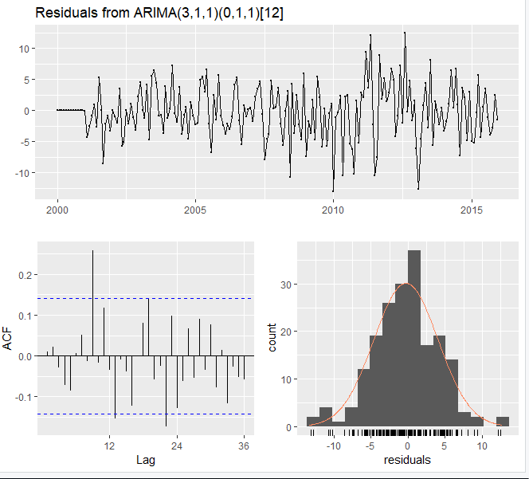

tsdisplay(m0$residuals)

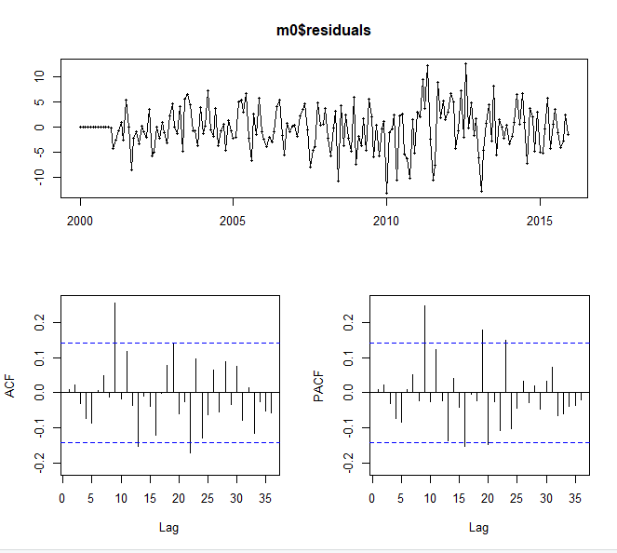

LjungBox(m0$residuals, lags=seq(length(m0$coef),24,4), order=length(m0$coef))

lags statistic df p-value

5 2.828145 0 0.000000000

9 16.981981 4 0.001948593

13 25.020068 8 0.001542432

17 28.484587 12 0.004696079

21 34.990826 16 0.003985800

f0 <- forecast(m0, h=h)

accuracy(f0,trnovr2)[,c(2,3,5,6)]

RMSE MAE MAPE MASE

Training set 4.329957 3.283853 3.994587 0.6365633

Test set 12.315054 10.750570 8.899807 2.0839598

The Auto Arima procedur results in ARIMA(3,1,1)(0,1,1) model.

This model shows satisfactory diagnostics. The residuals behave reasonably well. But there is white noise in the residuals. We will now explore some variations starting from this model, and check model ﬁt and forecast accuracy. The code below allows us to gather the results of several models.

**Question 7 Comparing different models**

getinfo <- function(x,h,...)

{

train.end <- time(x)[length(x)-h]

test.start <- time(x)[length(x)-h+1]

train <- window(x,end=train.end)

test <- window(x,start=test.start)

fit <- Arima(train,...)

fc <- forecast(fit,h=h)

a <- accuracy(fc,test)

result <- matrix(NA, nrow=1, ncol=5)

result[1,1] <- fit$aicc

result[1,2] <- a[1,6]

result[1,3] <- a[2,6]

result[1,4] <- a[1,2]

result[1,5] <- a[2,2]

return(result)

}

mat <- matrix(NA,nrow=54, ncol=5)

modelnames <- vector(mode="character", length=54)

line <- 0

for (i in 2:4){

for (j in 0:2){

for (k in 0:1){

for (l in 0:2){

line <- line+1

mat[line,] <- getinfo(turnover,h=37,order=c(i,1,j),seasonal=c(k,1,l))

modelnames[line] <- paste0("ARIMA(",i,",1,",j,")(",k,",1,",l,")[12]")

}

}

}

}

colnames(mat) <- c("AICc", "MASE_train", "MASE_test", "RMSE_train", "RMSE_test")

rownames(mat) <- modelnames

# best AICc

mat[mat[,1]==min(mat[,1])]

[1] 1071.9932924 0.6217361 2.0149677 4.2374425 12.0554940

#best MASE_train

mat[mat[,2]==min(mat[,2])]

[1] 1077.6216333 0.6179339 2.0704573 4.2699840 12.3279435

#best MASE_test

mat[mat[,3]==min(mat[,3])]

[1] 1080.2414751 0.6297766 1.9842648 4.2825882 11.9015030

#best RMSE_train

mat[mat[,4]==min(mat[,4])]

[1] 1071.9932924 0.6217361 2.0149677 4.2374425 12.0554940

#best RMSE_test

mat[mat[,5]==min(mat[,5])]

[1] 1080.2414751 0.6297766 1.9842648 4.2825882 11.9015030

Based on these analyses, we select 3 models that could bring us closer to the most suitable model:

**1. m0: ARIMA(3,1,1)(0,1,1) is the model selected by auto.arima. It shows acceptable ﬁt, forecasting accuracy and residual diagnostics.**

**2. m1: ARIMA(4,1,2)(0,1,1) shows the best AICc. AND rmse TRAIN**

**3. m2: ARIMA(4,1,2)(1,1,2) shows the best MASE and RMSE on the test set.**

**4. m3: ARIMA(2,1,2)(1,1,2) shows the best MASE on the training set.**

We now study these selected models in more detail.

> m1 <- Arima(trnovr1, order=c(4,1,2), seasonal=c(0,1,1))

> LjungBox(m1$residuals, lags=seq(length(m1$coef),24,4), order=length(m1$coef))

lags statistic df p-value

7 3.770133 0 0.0000000000

11 17.047356 4 0.0018924234

15 22.557016 8 0.0039820689

19 31.001801 12 0.0019687689

23 39.711675 16 0.0008576984

tsdisplay(m1$residuals)

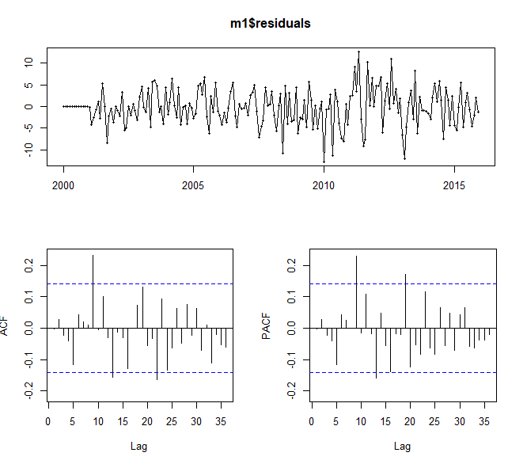

m2 <- Arima(trnovr1, order=c(4,1,2), seasonal=c(1,1,2))

> LjungBox(m2$residuals, lags=seq(length(m2$coef),24,4), order=length(m2$coef))

lags statistic df p-value

9 17.34121 0 0.000000e+00

13 25.43965 4 4.103911e-05

17 28.55160 8 3.799692e-04

21 34.96306 12 4.746937e-04

tsdisplay(m2$residuals)

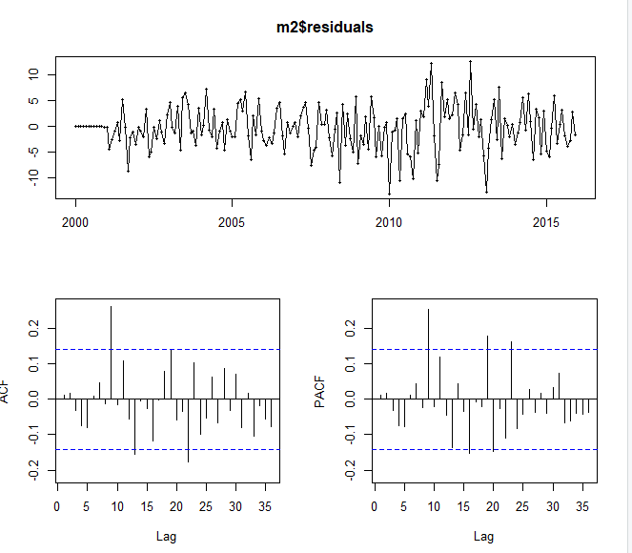

f2 <- forecast(m2, h=h)

m3 <- Arima(trnovr1, order=c(2,1,2), seasonal=c(1,1,2))

> LjungBox(m3$residuals, lags=seq(length(m3$coef),24,4), order=length(m3$coef))

lags statistic df p-value

7 13.67493 0 0.000000e+00

11 23.94541 4 8.191272e-05

15 33.84336 8 4.336906e-05

19 40.55516 12 5.813750e-05

23 48.48290 16 3.987646e-05

tsdisplay(m3$residuals)

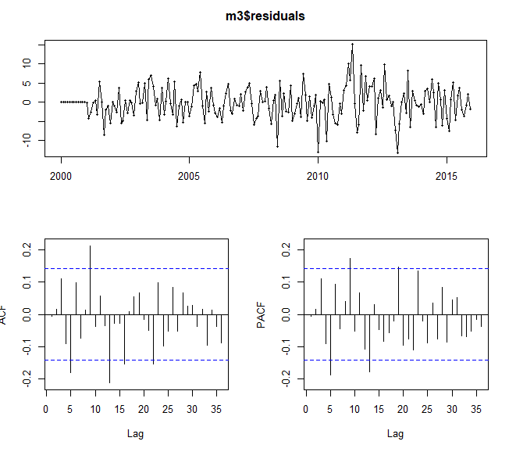

We bring together the relevant accuracy measures in the tables below.

a_m0 <- accuracy(f0,trnovr2)[,c(2,3,5,6)]

a_m1 <- accuracy(f1,trnovr2)[,c(2,3,5,6)]

a_m2 <- accuracy(f2,trnovr2)[,c(2,3,5,6)]

a_m3 <- accuracy(f3,trnovr2)[,c(2,3,5,6)]

a_train_a <- rbind(a_m0[1,], a_m1[1,], a_m2[1,], a_m3[1,])

rownames(a_train_a) <- c("a_m0", "a_m1", "a_m2", "a_m3")

a_train_a

RMSE MAE MAPE MASE

a_m0 4.329957 3.283853 3.994587 0.6365633

a_m1 4.225963 3.196396 3.883785 0.6196101

a_m2 4.271264 3.238430 3.944448 0.6277582

a_m3 4.262932 3.181605 3.890177 0.6167429

a_test_a <- rbind(a_m0[2,], a_m1[2,], a_m2[2,], a_m3[2,])

rownames(a_test_a) <- c("a_m0", "a_m1", "a_m2", "a_m3")

a_test_a

RMSE MAE MAPE MASE

a_m0 12.31505 10.75057 8.899807 2.083960

a_m1 12.37717 10.81792 8.961836 2.097015

a_m2 12.22645 10.65945 8.826867 2.066296

a_m3 12.83012 11.27924 9.361818 2.186440

As m0 and m1 have white noise so we can now choose from m2 and m3 we will go with m2 as it has least RMSE measure.

So we chose m2 **m2: ARIMA(4,1,2)(1,1,2) as our final model here.**

a_final <- Arima(turnover, order=c(4,1,2), seasonal=c(1,1,2))

summary(a_final)

Series: turnover

ARIMA(4,1,2)(1,1,2)[12]

Coefficients:

ar1 ar2 ar3 ar4 ma1 ma2 sar1 sma1 sma2

-0.9381 0.0194 0.3327 0.2506 0.1128 -0.8870 -0.8916 0.1624 -0.8375

s.e. 0.1041 0.1743 0.1601 0.0908 0.1326 0.1226 0.0504 0.1496 0.1286

sigma^2 estimated as 22.04: log likelihood=-647.34

AIC=1314.67 AICc=1315.75 BIC=1348.38

Training set error measures:

ME RMSE MAE MPE MAPE MASE ACF1

Training set 0.04265333 4.462709 3.45592 -0.3028667 3.934251 0.6022515 0.002314035

a_final_f <- forecast(a_final, h=24)

plot(a_final_f)

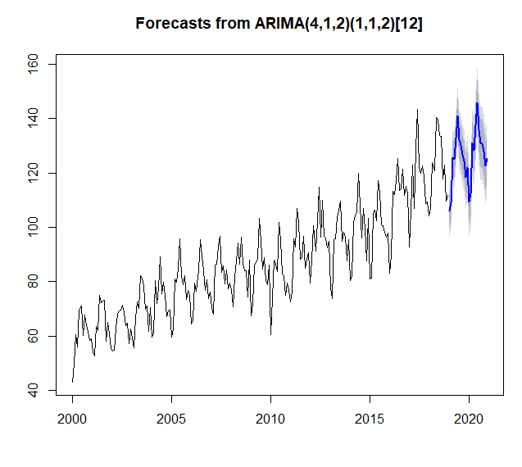

Now we will analyse different models accuracy measures and will choose the best one for final forecast.

Seasonal Naïve RMSE

RMSE MAE MAPE MASE

Test set 18.545039 16.562222 13.89789 3.210528

STL Method RMSE (exponential trend)

RMSE MAE MAPE MASE

a_fc1 4.546525 3.625724 4.259526 0.6318427

MMdM ETS Model

RMSE MAE MAPE MASE

15.38008 13.87397 11.62868 2.689420

ARIMA(4,1,2)(1,1,2) a_m2

RMSE MAE MAPE MASE

a_m2 12.22645 10.65945 8.826867 2.066296

We can see that RMSE of STL Method is the least so, we will choose that one.

